**Project On Car Resale Value prediction**

Powered by IBM India

Submitted by YAMINI PRIYA. N

MOCHERLA ABHILASH

MAINAMPATI POOJITHA

GANDAMANENI PHANEENDRA

**PROJECT ID PNT2022TMID36315**

Of

Department of Computer Science and Engineering

**J.N.N INSTITUTE OF ENGINEERING**

**90 ushaa garden ,kannigaipair ,Chennai periyapalayam highway,**

Tamil nadu601102

Mentor: D.pavunraj

**Industrial Mentor: prof swetha**

|  |  |  |
| --- | --- | --- |
| S.No | Title | Page No |
| 1 | **INTRODUCTION**  1.1 Project Overview  1.2 Purpose | 4 |
| 2 | **LITERATURE SURVEY**  2.1 Existing problem  2.2 References  2.3 Problem Statement Definition | 4  4  5 |
| 3 | **IDEATION & PROPOSED SOLUTION**  3.1 Empathy Map Canvas  3.2 Ideation & Brainstorming  3.3 Proposed Solution  3.4 Problem Solution fit | 6  6  7  8 |
| 4 | **REQUIREMENT ANALYSIS**  4.1 Functional requirement  4.2Non-Functional requirements | 9 |
| 5 | **PROJECT DESIGN**  5.1 Data Flow Diagrams  5.2 Solution & Technical Architecture  5.3 User Stories | 9  10  11 |
| 6 | **PROJECT PLANNING & SCHEDULING**  6.1 Sprint Planning & Estimation  6.2 Sprint Delivery Schedule  6.3 Reports from JIRA | 11  12 |

|  |  |  |
| --- | --- | --- |
| 7 | **CODING & SOLUTIONING (Explain the features added in the project**  **along with code)**  7.1 Feature 1  7.2 Feature 2  7.3 Database Schema (if Applicable) | 12  13  14 |
| 8 | **TESTING**  8.1 Test Cases  8.2 User Acceptance Testing | 14  14 |
| 9 | **RESULTS**  9.1 Performance Metrics | 17 |
| 10 | **ADVANTAGES & DISADVANTAGES** | 17 |
| 11 | **CONCLUSION** | 17 |
| 12 | **FUTURE SCOPE** | 17 |
| 13 | **APPENDIX** | 18 |

1.Introduction:-

1.1 Project overview:-

With difficult economic conditions, it is likely that sales of second-hand imported (reconditioned) cars and used cars will increase. In many developed countries, it is common to lease a car rather than buying it outright. After the lease period is over, the buyer has the possibility to buy the car at its residual value, i.e. its expected resale value. Thus, it is of commercial interest to sellers/financers to be able to predict the salvage value (residual value) of cars with accuracy.

1.2 Purpose:-

In order to predict the resale value of the car, we proposed an intelligent, flexible, and effective system that is based on using regression algorithms. Considering the main factors which would affect the resale value of a vehicle a regression model is to be built that would give the nearest resale value of the vehicle. We will be using various regression algorithms and algorithm with the best accuracy will be taken as a solution, then it will be integrated to the web-based application where the user is notified with the status of his product.

1. **LITERATURE SURVEY**
   1. **Existing problem**

The problem is defined as the optimised way to estimate insurance cost based on the manufacturer with some additional costs incurred by the Government in the form of taxes. As the existing methods for estimating the cost takes a lot oftime and energy and due to the increased price of new cars and the inability of customers to buy new cars due to the lack of

funds, used cars sales are on a global increase

* 1. **References**

At present, under the guidance ofthe new generation of information technology,the rapid accumulation of data, the continuous improvement of computing power, the continuous optimization of algorithm models, and the rapid rise of multi-scene applications have made profound changes in the development environment of Machine Learning

1. Kanwal Noor, 2017, Vehicle Price Prediction System using Machine Learning

Techniques International Journal of Computer Applications. Volume 167 - Number 9

1. Mariana Lusitania et al, (2009). Support vector regression analysis for price prediction in a vehicle leasing application [3] Richardson, M. S. (2009). Determinants of used vehicle resale value.
2. Listiani, M. (2009). Support vector regression analysis for price prediction in a car leasing application (Doctoral dissertation, Master thesis, TU Hamburg-Harburg).
3. T. D. Phan, "Housing Price Prediction Using Machine Learning Algorithms: The Case of

Melbourne City Australia", *2018 International Conference on Machine Learning and Data Engineering (iCMLDE)*, pp. 35-42, 2018.

1. K. Samruddhi and R. Ashok Kumar, "Used Car Price Prediction using K-Nearest Neighbor Based Model", *International Journal of Innovative Research in Applied Sciences and Engineering*, vol. 4, no. 3, pp. 686-689, 2020.

6[6]O. Celik and U. O. Osmanoglu, "Prediction of The Prices of Second-Hand Cars", *Avrupa Bilim ve Teknoloji Dergisi*, no. 16, pp. 77-83, Aug. 2019.

**2.3 Problem Statement Definition**

The main aim of this project is to predict the price of used cars using the various Machine Learning (ML) models. This can enable the customers to make decisions based on different inputs or factors namely

1. **IDEATION & PROPOSED SOLUTION 3.1 Empathy Map Canvas**

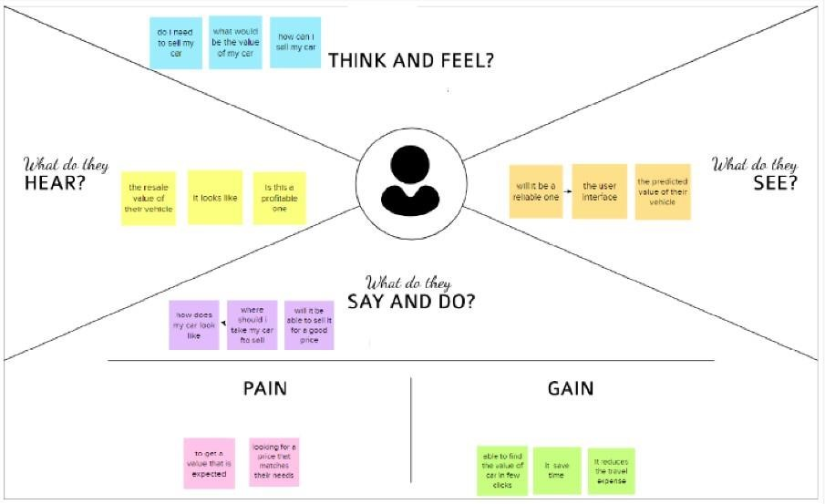

* 1. **Ideation & BrainstormingSTEP 1:**
     + Prediction using Car image.
     + By using the exterior and interior image ofthe car.
     + The value will be predicted based on the appearance of the car.If there any damage or n numbers scratches the car resale value will be quite affected.
     + By using neural network value ofthe car can be predicted.
     + Neural network algorithm is developed by considering the human brain that takes a set of units as input and transfers results to a predefined output.

STEP 2:

* + - The main objective of this project is to predict the Prices of used cars, compare the prices and also estimate the lifespan of a particular car.
    - Insurance, Company claims,etc.
    - Regression Algorithm is used to predict the value.
    - Regression model based on k-nearest neighbour machine learning algorithm was used to predict the price of a car.

**STEP 3:**

* + - Prediction using engine car condition. oUser should upload engine sound in the format of audio file.
    - By using Convolutional Neural Networks methodology price can be predicted.
    - CNNs for Machine Learning on sound data by spectrogram approach that was just converts each song (or song segment) into a spectrogram: a two dimensional matrix8

**STEP 4:**

* + - Economic Conditions.
    - Kilo-metres Covered.
    - Its mileage (the number of kilometres it has run) and its horsepower
    - Car prediction using XGBoost algorithm accurate results will be monitored.
    - XGBoost as a regression model gave the best MSLE and RMSE values

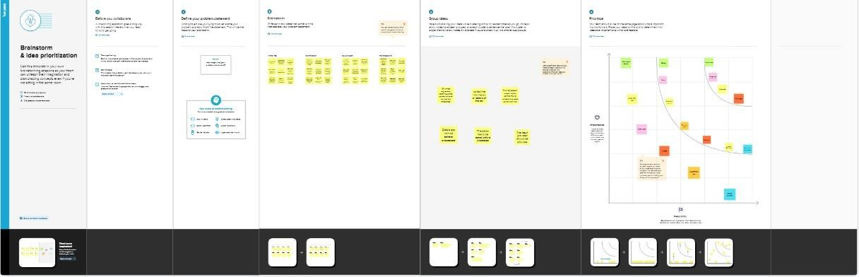

* 1. **Proposed Solution**

|  |  |  |
| --- | --- | --- |
| **S.No** | **Parameter** | **Description** |
| 1 | Problem Statement (Problem to be solved) | To develop a webpage to predict the resale value of a car |
| 2 | Idea / Solution description | To train the system with the dataset using a regression model |
| 3 | Novelty / Uniqueness | By using the optimal regression model to predict the value in a less amount to time and predict its value |
| 4 | Social Impact / Customer Satisfaction | The customer can get an idea about the resale value of their car .to have an idea whether to  sell their vehicle or not based on their financial condition |
| 5 | Business Model (Revenue Model) | The web based application has a friendly UI for the customer to enter their vehicles detail and the system predicts the value within few seconds |
| 6 | Scalability of the Solution | tHE solution given by the trained system is efficient and is nearly accurate value of the vehicle. |

* 1. **Problem Solution fit**

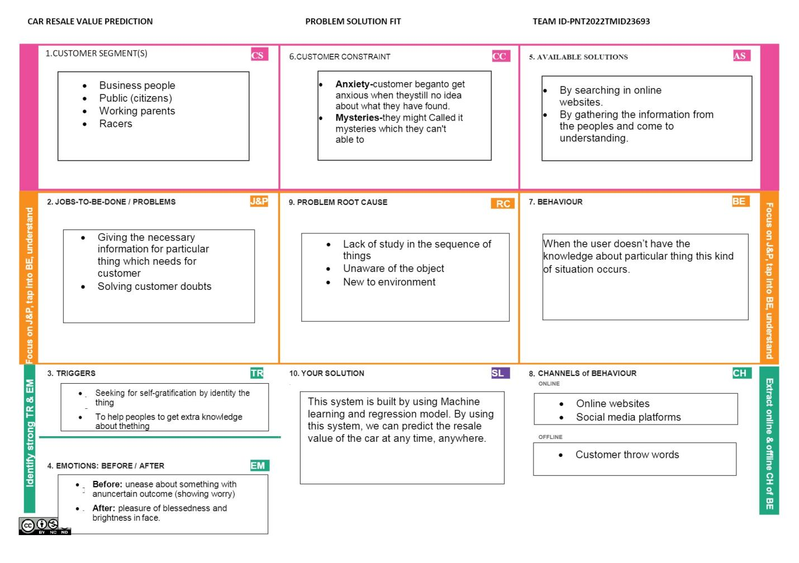

1. **REQUIREMENT ANALYSIS**

**4.1 Functional requirement**

The functional Requirements ofthis projects involves the better understanding of

Pre-processing, Application designing using HTML & CSS and IBM Watson Cloud. IBM

Watson provides the services such as Database, deployment etc. Hardware requirements

Operating system- Windows 7,8,10

## Software Requirements

* Python
* Pycharm
* PIP 2.7
* Jupyter Notebook
* Chrome

**4.2 Non-Functional requirements**

The Non - Functional Requirements ofthis project are,

* Highly accurate Image Predictive model
* Better user responsive web application
* Cloud database for storing the informations

1. **PROJECT DESIGN**
   1. **Data Flow Diagrams**

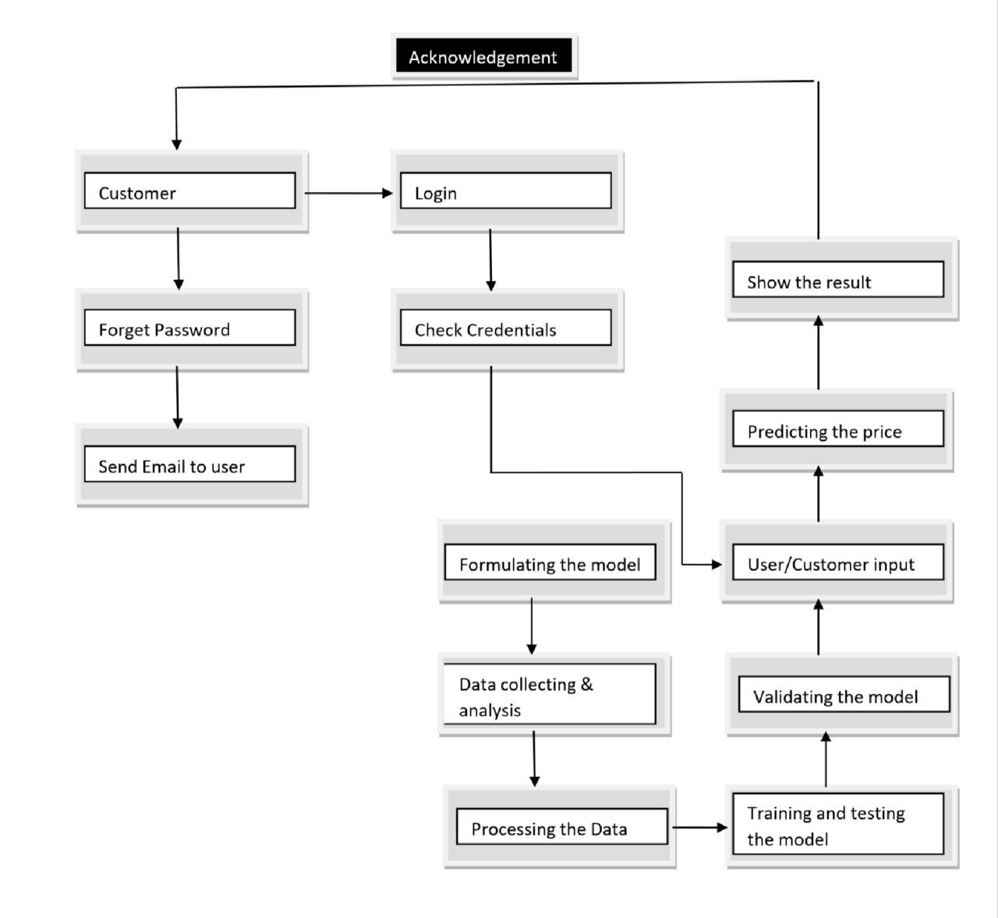

* 1. **Solution & Technical Architecture**

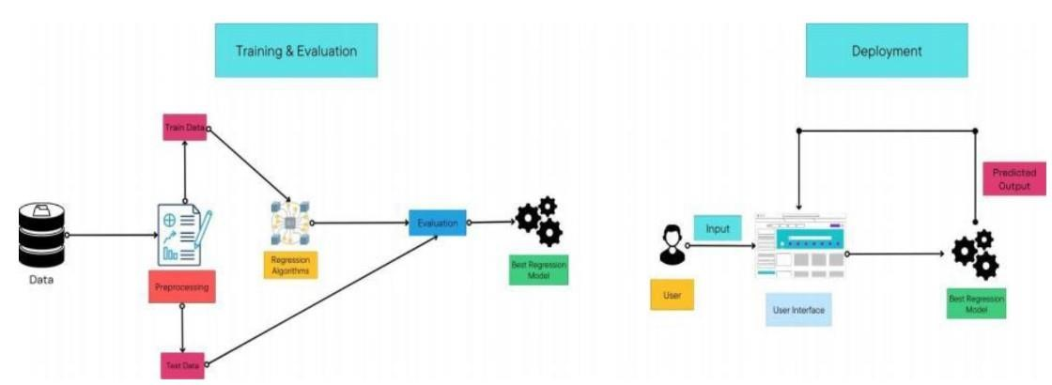

### 5.3 User Stories

|  |  |  |  |  |  |  |
| --- | --- | --- | --- | --- | --- | --- |
| **Sprint** | **Functional**  **Requirement**  **(Epic)** | **User**  **Story**  **Number** | **User Story /**  **Task** | **Story**  **Points** | **Priority** | **Team**  **Members** |
| Sprint- 1 | Home Page | USN-1 | As a user, I can view the home page of the web application. | 20 | Medium | Yamini priya.n |
| Sprint- 2 | Car resale value display | USN-2 | As a user, I can be redirected to  the data entry page | 20 | Medium | Mocherla abhilash |
| Sprint- 3 | Data Entry | USN-3 | As a user, I can enter my car details in the re4quired fields. | 20 | Medium | Mainampati  poojitha |
| Sprint- 4 | Resale Value Prediction | USN-4 | As a user, I expect the application to predict the esale value of my car. | 20 | Low | Gandamaneni  phaneendra |

## 6.PROJECT PLANNING

### 6.1 Sprint Planning and Estimation

|  |  |  |  |  |  |  |
| --- | --- | --- | --- | --- | --- | --- |
| **Sprint** | **Total Story**  **Points** | **Duration** | **SprintStar tDate** | **Sprint End Date(Plann ed)** | **Story**  **PointsComplete d (as on Planned**  **End Date)** | **Sprint Release**  **Date(Actual)** |
| Sprint- 1 | 20 | 6 Days | 24 Oct  2022 | 29 Oct 2022 | 20 | 29 Oct 2022 |
| Sprint- 2 | 20 | 6 Days | 31 Oct  2022 | 05 Nov  2022 | 20 | 05 Nov 2022 |
| Sprint- 3 | 20 | 6 Days | 07 Nov  2022 | 12 Nov  2022 | 20 | 12 Nov 2022 |
| Sprint- 4 | 20 | 6 Days | 14 Nov  2022 | 19 Nov  2022 | 20 | 19 Nov 2022 |

### 6.2 Sprint Delivery Schedule

* Pre -requisites
* Import Required libraries
* Collect Data Set
* Pre the process the data
* Choose the Appropriate Model
* Train the model on IBM
* Integrate with Flask endpoint
* Index..html
* Registration form.html
* Flask application
* App.py

**7. CODING & SOLUTION**

### 7.1 Feature 1

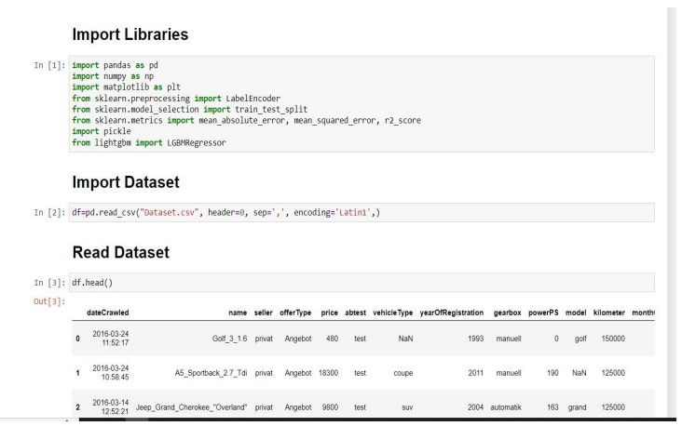

### 7.2 Feature 2

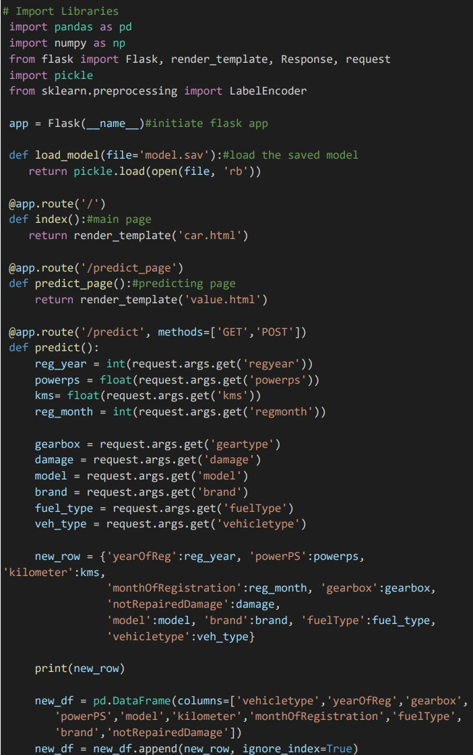

**7.3 Database Schema (if Applicable)**

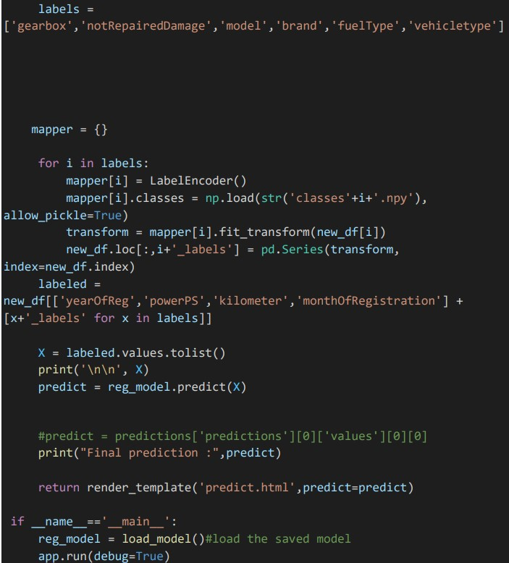

## 8. TESTING

### 8.1. Test Cases

1. User Login and Registration test
2. Database Update test
3. Prediction test

### 8.2. User Acceptance Testing

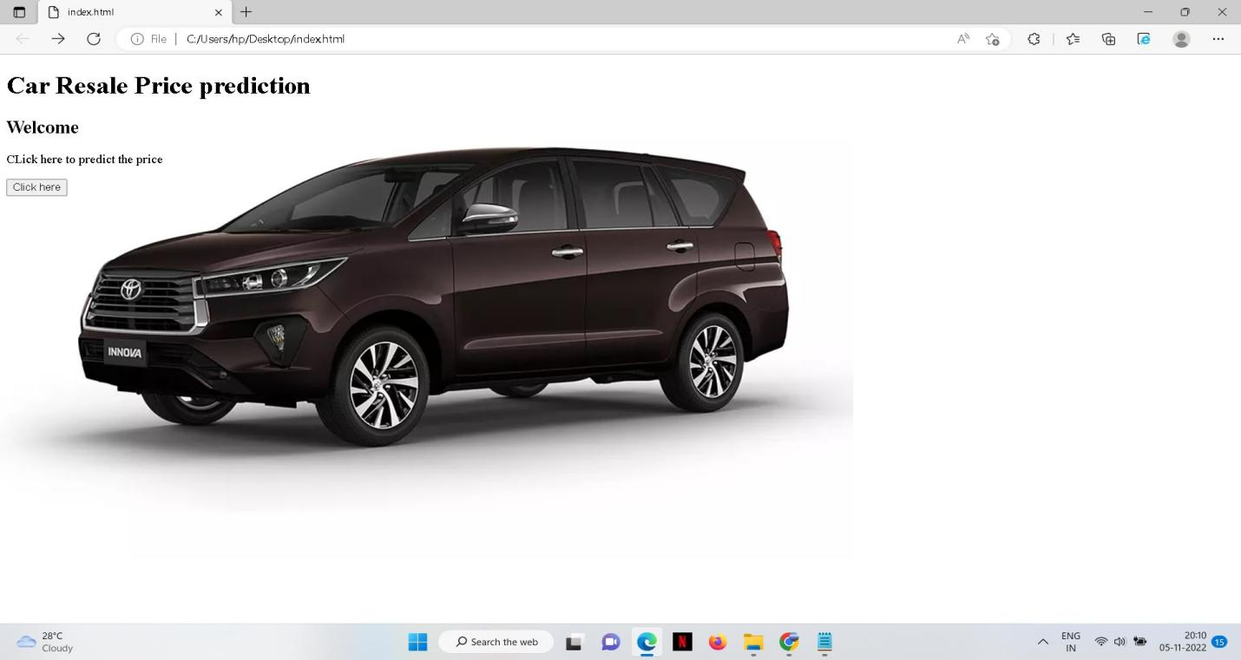

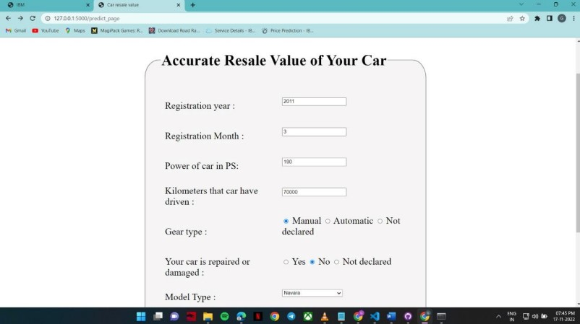

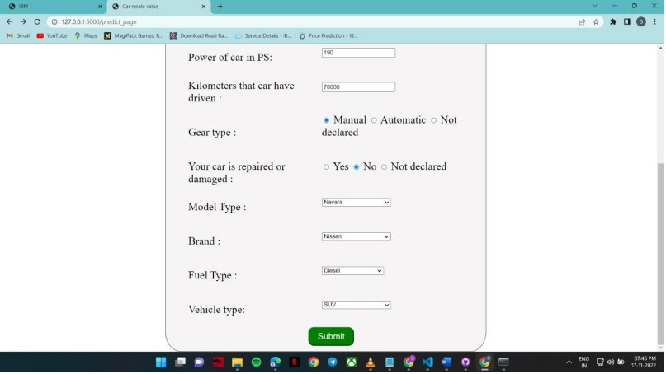

## The login web page is tested with the invalid user information to check the invalid login

**testing into the webpage.**

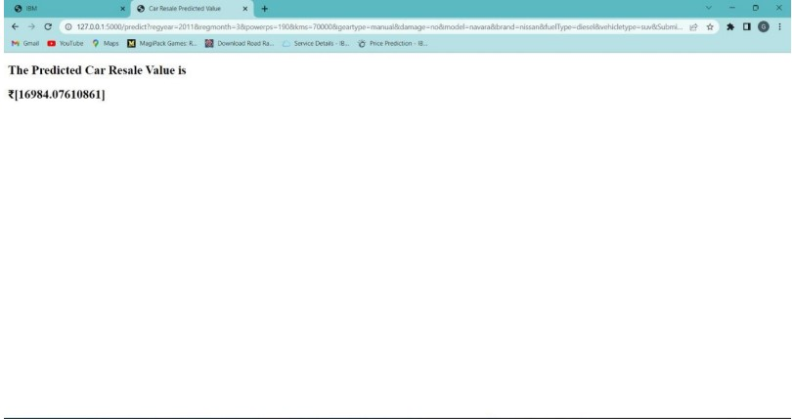

**Estimated Car resale value is 16984.07610861**

## 9. PERFORMANCE

### 9.1 Performance metrics

{'mae': 1325.112086905962,

'mse': 9577053.62710202,

'rmse': 3094.6815065692977,

'rmsle': 8.03744027403009,

'r2': 0.8661221626879432,

'adj r2 score': 0.8661152969113608}

The model is tested with the various damaged car images which is not used during the training and validation ofthe model which also shows that the model works with the accuracy of about

98% in the overall performance

## 10. ADVANTAGES AND DISADVANTAGES

* To develop an efficient and effective model which predicts the price of a used car according to the user's inputs and achieve good accuracy.

**CONS:**

* Less effective

## 11. CONCLUSION

The increased prices of new cars and the financial incapability of the customers to buy them, Used Car sales are on a global increase. Therefore, there is an urgent need for a Used Car Price Prediction system which effectively determines the worthiness of the car using a variety of features. The proposed system will help to determine the accurate price of used car price prediction.

## 12.FUTURE SCOPE

In future this machine learning model may bind with various websites which can provide real time data for price prediction. Also we may add large historical data of car price which can help to improve accuracy of the machine learning model. We can build an android app as a user interface for interacting with users. For better performance, we plan to judiciously design deep learning network structures, use adaptive learning rates and train on clusters of data rather than the whole dataset.

**Github Repo:** <https://github.com/IBM-EPBL/IBM-Project-23693-1659893453>

## 13. APPENDIX App.py

# Import Libraries import pandas as pd import numpy as np from flask import Flask, render_template, Response, request import pickle from sklearn.preprocessing import LabelEncoder

app = Flask(__name__)#initiate flask app

def load_model(file='model.sav'):#load the saved model return pickle.load(open(file, 'rb'))

@app.route('/') def index():#main page return render_template('car.html')

@app.route('/predict_page') def predict_page():#predicting page return render_template('value.html') @app.route('/predict', methods=['GET','POST']) def predict():

reg_year = int(request.args.get('regyear')) powerps = float(request.args.get('powerps')) kms= float(request.args.get('kms')) reg_month = int(request.args.get('regmonth'))

gearbox = request.args.get('geartype') damage = request.args.get('damage') model = request.args.get('model') brand = request.args.get('brand') fuel_type = request.args.get('fuelType') veh_type = request.args.get('vehicletype')

new_row = {'yearOfReg':reg_year, 'powerPS':powerps, 'kilometer':kms,

'monthOfRegistration':reg_month,

'gearbox':gearbox,

'notRepairedDamage':damage,

'model':model, 'brand':brand, 'fuelType':fuel_type,

'vehicletype':veh_type}

print(new_row)

new_df = pd.DataFrame(columns=['vehicletype','yearOfReg','gearbox',

'powerPS','model','kilometer','monthOfRegistration','fuelType',

'brand','notRepairedDamage']) new_df = new_df.append(new_row, ignore_index=True)

labels =

['gearbox','notRepairedDamage','model','brand','fuelType','vehicletype'] mapper = {}

for i in labels:

mapper[i] = LabelEncoder() mapper[i].classes = np.load(str('classes'+i+'.npy'),

allow_pickle=True)

transform = mapper[i].fit_transform(new_df[i])

new_df.loc[:,i+'_labels'] = pd.Series(transform,

index=new_df.index)

labeled = new_df[['yearOfReg','powerPS','kilometer','monthOfRegistration'] + [x+'_labels' for x in labels]]

X = labeled.values.tolist() print('\n\n', X)

predict = reg_model.predict(X)

#predict = predictions['predictions'][0]['values'][0][0] print("Final prediction :",predict)

return render_template('predict.html',predict=predict)

if __name__=='__main__': reg_model = load_model()#load the saved model app.run(debug=True)